**1. SMART GAS SYSTEM**

# ABSTRACT

Home fires have been taking place frequently and the threat to human lives and properties has been growing in recent years. Liquid Petroleum Gas (LPG) is highly inflammable and can burn even at some distance from the source of leakage. Most fire accidents are caused because of a poor-quality rubber tube or because the regulator is not turned off when not in use. Therefore, developing a gas leakage alert system is essential. Hence, this paper presents a gas leakage alert system to detect the gas leakage and alarm the people onboard.

**PROBLEM STATEMENT**

The growing dependence on natural gas in diverse residential and industrial applications has heightened the potential for gas leak incidents. These leaks present significant dangers to life, property, and the environment due to the combustible and harmful properties of the gas. Although safety measures have been put in place, the timely identification of gas leaks remains a critical challenge. Current gas detection systems frequently lack the necessary sensitivity, real-time monitoring capabilities, and cost-effectiveness required for widespread implementation.

# 

# MIND MAP

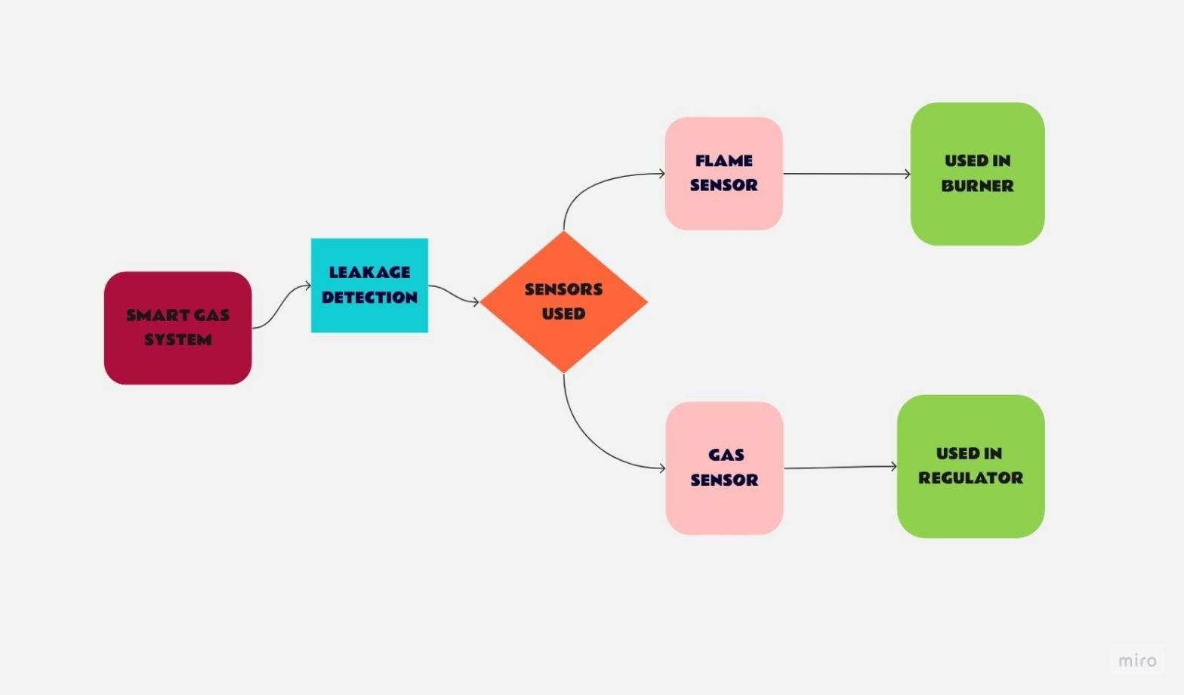

**CIRCUIT DIAGRAM**

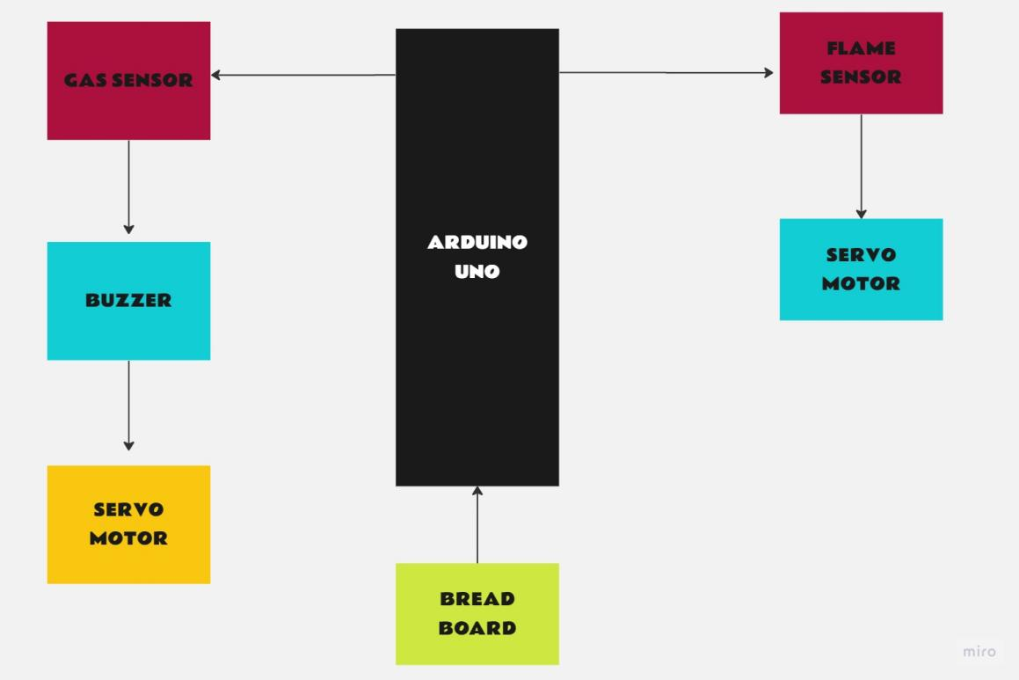



**SOLUTION**

The results for gas leakage detection using an Arduino, gas sensor, servo motor, and buzzer with IoT integration would typically involve real-time monitoring and alerting. The gas sensor detects the gas leakage, triggering the Arduino to activate the servo motor and buzzer for immediate response. Additionally, IoT connectivity enables remote monitoring and notifications, allowing users to receive alerts or check the status of the system through the Internet. It's important to ensure proper calibration and testing of the system to ensure reliable detection and response to gas leaks.